**“Motion Estimation Using Optical Flow”**

by Mahendra Basyal, University of Houston- Downtown

2019

Senior Project

Dr. Yuchou Chang

04/29/2019

**Abstract**

Described here is a method for using a combination of multiple optical flow models to enhance accuracy and efficiency while computing motion estimation. The Horn and Schunck optical flow model has low accuracy, especially for images with complex texture. We have proposed a modification of energy function and brightness constraint equations used in Horn and Schunck optical flow model. Energy function and brightness constraint were studied from Fractional-Order optical flow model, where Euler-Lagrange equation is used to minimize energy function and fractional-order Taylor series expansion is applied in the brightness constraint equation of Horn and Schunck optical flow. Instead of using a same window mask, change in size is applied according to image size in order to further enhance the accuracy. The proposed method makes use of two traditional (H&S model) and modern (Fractional-Order) optical flow models, applies changes to traditional model to enhance its performance.

**Table of Content**

1. **Introduction:** Motion Estimation and Optical Flow     ……………………………….…. 4
2. **Background:**     …………………………………………………………….…….............. 5
3. **Project:** Motion Estimation Using Optical Flow       ……………………………….……. 6

                  3.1.  Horn and Schunck ………………………………………………………… 7

                               3.1.1.   Introduction ……………………………………………………. 7

3.1.2. Characteristics ………………………………………………… 7

3.1.3 Energy Function ………………………………………………... 9

3.1.4 Brightness Constraint …………………………………………... 9

3.1.5 Corner Detection ……………………………………………….. 10

                  3.2.  Fractional-Order …………………………………………………………... 11

                               3.2.1.   Introduction ……………………………………………………. 11

3.2.2. Characteristics ………………………………………………… 12

3.2.3 Energy Function ………………………………………………... 13

3.2.4 Brightness Constraint …………………………………………... 13

                  3.3.  Modified Parameters ……………………………………………………… 14

                               3.1.1.   Euler Lagrange ……………………………………...…………. 14

3.1.2. Median Filter ……………………………………….………… 15

3.1.3 Reduce Smoothness Effect ……………………………………... 16

1. **Results:**     ……………………………….………………………………………………… 18
2. **Conclusion:**     ……………………………………………………………….…………… 21
3. **Reference:**       ……………………………….……………………………………………. 23

**1)Introduction**

Estimating motion from image data sequences is an important topic in computer vision and has been researched and studied extensively over the past few decades. The process of determining optical flow is generally carried out through utilizing brightness constancy constraint equation (BCCE), which makes use of spatiotemporal derivatives of image intensity [1]. When image sequences are used with characteristics such as straight moving edge and narrow aperture, we run into ill-posed BCCE problem. In order to overcome this ill-posed BCCE we can use several methods, from which two of the most common are Lucas-Kanade, and Horn and Schunck technique. Lucas Kanade method involves the optimization of local energy functional or the frequency based on minimization. Horn and Schunck method involve global energy functional, which refers to methods that determine optical flow through minimization of global energy functional. These techniques are used due to their efficiency and high level of performance, but they also have their own positives and negatives. Local methods offer robustness to noise but lack the ability to produce dense optical flow fields, while global techniques produce full optical fields, but are much sensitive to noise [1].

This project is more based on enhancing motion discontinuity preserving approaches, which mostly uses global techniques in order to create dense optical flow field. Besides, Horn and Schunck method, Fractional-Order method is popular for motion estimation due to its higher accuracy and level of performance. Although both methods use global techniques, Fractional-Order method involves modern approach to the Horn and Schunck method resulting in more complex calculations in order to get higher performance. A more detailed evaluation and comparison between these two methods can be found in section below called “Project Report”.

Optical flow is the apparent motion of objects in image sequences that results from relative motion between the objects and the imaging perspective. It is our attempt to estimate the 2D-projection of 3D-real world motion [1]. Optical flow mainly uses two kinds of constraint in order to estimate optical flow: the smoothness constraint and the brightness constancy constraint. Optical flow methods estimate the motion between two consecutive image frames that were captured at different times. A flow vector is calculated for every pixel, and these pixels represent approximations of image motion that are based on spatial derivatives. Optical flow is a key concept in this project and behaves as an operator in the pixel difference calculations. In this project, improvements in smoothness constraint and brightness constancy constraint is proposed in the traditional Horn and Schunck method. Due to the simplicity of Horn and Schunck method, changes are applied only on major constraints in order to avoid complexity of the algorithm.

**2)Background**

Motion estimation and optical flow are experienced by us every day in our life as we move or the objects around us move. Because all these activities happen in 3D real world, motion estimation using optical flow is a way to estimate 2D projection of 3D world by a machine. For past few decades, there has been a lot of research to create and improve motion estimation methods. Major application of optical flow is in the field of artificial intelligence and robotics, where computing the optical flow for the image or video stream that comes through the machine’s visual sensors help machine navigate in the space and avoid obstacles. Optical flow is also used in digital cameras for image stabilization and used for video compression algorithms to medical imaging. Optical flow plays a major role when it comes to computer vision and AI development.

Along with optical flow and motion estimation comes complex calculations. Unlike machine language, most of optical flow methods consist of mathematical variables and calculations. Traditional methods such as Horn and Schunck contain fewer complex equations compared to modern optical flow methods such as Fractional-Order method. Because of the enhancement in machine performance year after year, optical flow methods have been changing recently in order to calculate bigger data, become time efficient and increment in overall performance.

**3)Project**

Horn and Schunck method, and Fractional-Order method are two major differential techniques used in this project for motion estimation using optical flow. Both techniques determine optical flow through minimization of a global energy functional. In this project, I have proposed to modify the brightness constancy constraint and the smoothness constraint used in Horn and Schunck optical flow model to reflect closely to the constraints from Fractional-Order optical flow model. These two constraints play major role in the enhanced results and performance we get from Fractional-Order method.

Octave was used for programming instead of MATLAB due to the university licensing. Initially Octave 4.4.1 was used to edit the algorithm, then octave 5.0.1 was used to execute the algorithm and get results. Octave 5.0.1 version was released in March and had significant improvements than earlier version. For this project, image package was mainly used from Octave forge to calculate the dense optical flow fields, with version 5.0.1 all packages in Octave forge came preinstalled making it easy for the user to execute the algorithm without having to install packages separately. Horn and Schunck optical flow model was executed on Octave while fractional-Order optical flow model was studied in a research article to evaluate the major constraints, their similarities and differences.

**3.1) Horn and Schunck**

3.1.1) Introduction

Berthold K.P. Horn and Brian G. Schunck from Artificial Intelligence Laboratory in Massachusetts Institute of Technology published an article related to determine optical flow in 1980. The article argued that, Optical flow cannot be computed locally, since only one independent measurement is available from the image sequence at a point, while flow velocity has two components [2]. Instead of using local minimization, Horn and Schunck proposed to use global minimization along with two constraints which provided the ability to compute dense optical flow, and globality in order to find the best solution based on flow from the whole image. Since then Horn and Schunck method has been successfully implemented on various computer vision applications.

3.1.2) Characteristics

Two major parameters are used in Horn and Schunck method to calculate optimum motion of optical flow. The number of iterations is used to identify how much loop is needed for simulation and smoothing is used in every iteration to smoothen out to produce best motion of optical flow. Partial derivative is used to get optimum optical flow image and the magnitude [1]. There are three types of partial derivative (Ix), (Iy), and (It). Ix is based on x-axis, Iy is based on y-axis, and It is based on time. Velocity u and v are computed before the executing the optical flow method. The optical flow simulation results are displayed with max flow value and flow range which consists of u – horizontal displacement and v – vertical displacement value.

Change in window size of images helps compute optical flow faster and provides higher overall performance.

Variation of window size and parameter will be discussed in detail in section 3.3) Modified Parameters.

Parameter variation is change in values of parameters that deal with image processing.

Start

Type of displacement

Variation of window size

Partial derivative derivation, Ix, Iy and It

Execution

Computation of U and V

Results Displayed

Parameter Variation

End

Figure 3.1.2) Horn and Schunck Algorithm Chart. [1]

3.1.3) Energy Function

Horn and Schunck method was the first global method that introduced a global constraint of smoothness over the computed flow field. The energy functional constructed by Horn and Schunck is listed below.

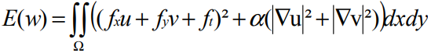[1]

In the equation above *f*x denotes the partial derivative of f with respect to x, u is the horizontal displacement, v is the vertical displacement, and |nabla u |2= (ux2 + uy2)1/2 [1]. If the displacement between the frames is small enough, the grey value will not drastically change from frame to frame.

The energy functional introduces two assumptions [1]. First, the grey value constancy assumption, which imposes constancy over the grey value image feature and tells us that the grey value doesn’t change over time. Second, the flow field smoothness assumption, which imposes additional constraints on the solution and tells us that the flow field that we are trying to compute must be globally smooth. Horn and Schunck assumed as an additional constraint that the optical flow is varying smoothly in the sense that neighboring object points have almost the same velocity [1].

3.1.4 Brightness Constraint

Horn and Schunck derived an equation that relates the change in image brightness at a point to the motion of the brightness pattern. Let the image brightness at the point (x, y) and the image plane at time t be denoted by E (x, y, t) [2]. The brightness of a particular point in the pattern is constant, so that dE/dt = 0 [2]. Using the chain rule for differentiation we see that, (∂E/∂x) dx/dt + (∂E/∂y) dy/dt + (∂E/∂t) = 0. Let u = dx/dt and v = dy/dt, then we can see that we have a single linear equation in the two unknowns u and v, Exu + Eyv + Et = 0, we can go further and write the equation as (Ex, Ey) (u, v) = -Et [2].

Figure 3.1.4) The basic rate of change of image brightness equation constrains the optical flow velocity. The velocity (u, v) has to lie along a line perpendicular to the brightness gradient vector (EX, EY). The distance of this line from origin equals Et divided by magnitude of (EX, EY) [2].

v

(EX, Ey)

Constraint line

u

We cannot, however, determine the component of the movement in the direction of the iso-brightness contours, at right angles to the brightness gradient. As a consequence, the flow velocity (u, v) cannot be computed locally without introducing additional constraints [2].

3.1.5) Corner Detection

Corner detection was done using gaussian method to calculate optical flow and pyramid flow. Corner detection serves as a feature point for sparse optical flow. Two images of same object captured with different angle and different time were used to conduct corner detection. The method first converts image into black and white image, and then examines the optical flow. After the optical flow is examined, it finds the major edges that were found in the dense optical flow field and then places key points along the edge.

For corner detection Lucas Kanade method was used. The image size used to test the method were 512 * 512, and obtained results were able to properly identify edges in the image sequence. Pyramid flow was used to compress images, normally reduce size by two times for each image, and by doing optical flow on each layer of pyramid, to get rid of the small motion constraint. We start the process from the lowest resolution, then use iterative optical flow to estimate potential motion velocity at this level and then expend it to a higher resolution as initial velocity for this level to apply Lucas Kande iteratively. Corner Detection results can be found in section called results.

**3.2) Fractional – Order**

3.2.1) Introduction

The accuracy of the motion estimation with the Horn and Schunck optical flow model is greatly reduced when image sequence includes complex texture and nonrigid motion. The traditional Horn and Schunck method fails to preserve the motion discontinuity. When applied to image sequences which include different adjoined motion objects, the edge of the optical flow field between different motion regions becomes very blurry and the motion object outline is unidentifiable.

Fractional-Order method was first used in a brightness constraint equation of the Horn and Schunck method in an attempt to preserve motion discontinuity [3]. Fractional-Order method is widely used nowadays because of its ability to preserve the texture details of homogenous regions while highlighting edge points at the same time. Because of this advantage widespread usage of Fractional-Order method is in image processing, such as image denoising, image enhancement and motion estimation. There have been attempts to use fractional-order smoothing constraint in Horn and Schunck method to preserve discontinuity of motion estimation, but it does not consider the correlation of the pixel intensity [3].

3.2.2) Characteristics

Fractional-Order method uses many fractional derivatives and differential masks for overall higher performance compared to Horn and Schunck method [3]. There are multiple fractional-order models that are used according to requirement, each differing with the order of fractional derivatives. The number of differential masks used in the model reflects to its performance, higher the number of differential masks better the performance. The fractional-order model studied in this project uses six two dimensional fractional differential masks. There are Wxx(µ) (k), Wxy(µ) (k, z), Wxt(µ) (k, p), Wyy(µ) (z), Wyx(µ) (k, z), Wyt(µ) (z, p) where µ is the order of fractional differentials [3].

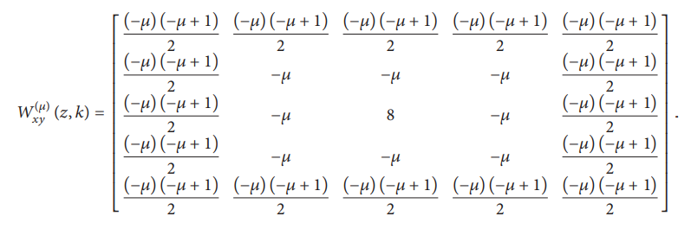[3]

Wxx(µ) (k) is defined as the two-dimensional fractional differential mask of dual derivatives on the x-axis [3]. The two-dimensional fractional derivatives of order µ of a discrete image brightness function I (i, j, t) on the x-axis can be defined as in the formula below.



3.2.3) Energy Function

The Euler-Lagrange equation was applied in the studied paper to minimize energy function. Fractional derivatives have played a significant role in engineering, science and pure and applied mathematics in recent years. When the derivatives are of integral order only, the results of fractional calculus of variations reduce to those obtained from classical calculus of variation. Fractional-Order method can be modeled more accurately using fractional derivative along with Euler-Lagrange equation.

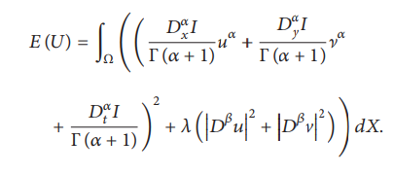

Energy function noted as E(U) in the left is computed to Euler- Lagrange equation. When α = 1, the fractional-order variational optical flow model can be seen as the Horn and Schunck first order variational model. When α = 2 it can be seen as generalization of integer order variational optical flow model [4].

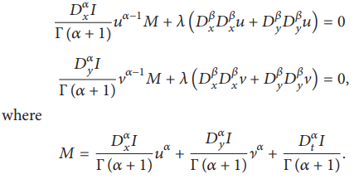

3.2.4) Brightness Constraint

Fractional-Order method uses the same brightness constraint equation of the Horn and Schunck methods with the addition of the fractional-order Taylor series expansion [3].



**3.3) Modified Parameters**

This project is mainly focused on energy function and brightness constancy constraints as these two are the main constraints that compute optical flow. In the sections above equations and details of each constraints are listed for both Horn and Schunck method, and Fractional-Order method. Complex fractional calculus is used in energy function constraint of fractional-order, and simply couldn’t be modified to be used as expected in Horn and Schunck method.

Preserving motion discontinuity was the main reason for using fractional-order method instead of Horn and Schunck method. While searching for possible solutions to reflect fractional-order constraints, many researches that were based on improving and modifying Horn and Schunck method were studied. It turns out it is easier to modify Horn and Schunck method with adding median filters and reducing smoothing effects. The proposed parameter modifications were studied in articles related to enhancing Horn and Schunck method while preserving motion discontinuity.

Beside preserving motion discontinuity, changes in image color filters, size, lambda value, and few other variables were done and executed. Because fractional-order method uses different window masks according to image size, change in lambda value was proposed to see the change in accuracy and results. Lambda value was set to 10 during the initial execution and was decreased accordingly to see the changes in the optical flow field.

3.3.1) Euler Lagrange

In order to deal with the noise and illumination changes in the real-world images, the fusion of two images gradient is used for computing Euler-Lagrange equations applying the variational method. The coefficients of Euler-Lagrange equations have been changed to contain both the gradient of the two images. Horn and Schunck implies on brightness constancy constraint, the assumption implies that the pixel in one frame may have another corresponding pixel in the other frame with the same brightness. Consider image sequence I1(x, y) and I2(x + u, y + v), where (x, y) denotes the pixel coordinate in image domain Ω, and (u, v) optical flow field [5]. With smoothness assumption, the classical global variational model can be written as:

[5]

From the equation above I1 and I2 indicate image sequence, Since the scene are continuous there exists many states that have not been captured between I1 and I2. We get brightness constancy for Ia as Ia(x, y) = I1(x - (1 - a)u, y – (1 - 1) v), Ia(x, y) = I2(x + au, y + av) [5]. The modified Euler Lagrange equation can be listed as:

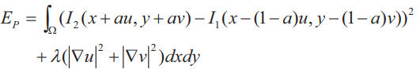[5]

If a equals 1 then the parameterized model will be the same as classical model, so the parameter is set to 0.5 [5]. Values of a can be changes according to images noise and illumination.

3.3.2) Median Filters

Noise can cause many problems in a digital image quality. Impulse noise is one of the most common noise found in digital images. There can be several factors causing this such as malfunctioning camera sensors, faults in analog to digital conversion, failure of memory locations in storage, interference of noise during stat transmission and bit errors in transmission [6]. Impulse noise can severely degrade the quality of the image, which may affect the subsequent process such as segmentation, detection, and classification, due to information lost.

Median filter is one of the popular methods to reduce impulse noise level in digital image. Standard median filter was introduced in 1971 by Tukey. This non-linear filter works by using a sliding window approach, where the center pixel value defined by the sliding window is being replaced by the median value samples within this window. The performance of the SMF is low when the corruption level is more than 60% [6]. Block diagram below shows a method which can be used to filter image accurately [6].

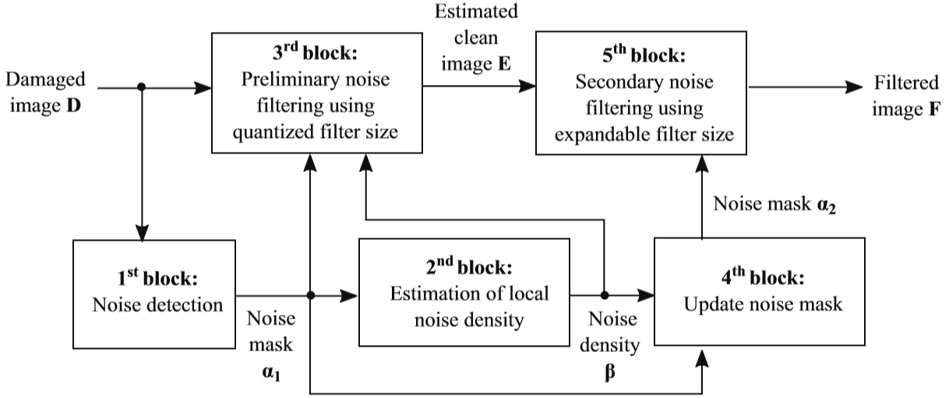

Figure 3.3.2) Image Filtering Steps [6]

3.3.3) Reducing Smoothing Effects

Smoothing process is preserved in the interior of moving objects, but it is weakened across motion discontinuities. A modification of the Horn and Schunck method can be obtained by computing the mean values of u’ and v’ and by the means of median filtering operation.

(u’, v’) = Median {(u, v) € W3} where W3 is a 3*3 window centered at the vector location [7].

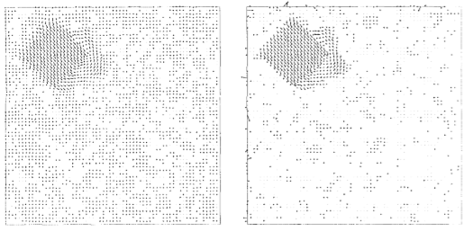

Figure 3.3.3) Reduced Smoothness Effect [7]

Optic flow fields obtained for the synthetic sequence by the original Horn and Schunck algorithm (Left) and by the modified algorithms with median filters in the (Right) [7].

**4)Results**

Corner Detection Results

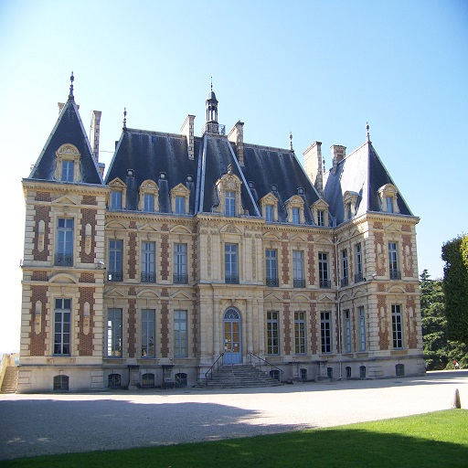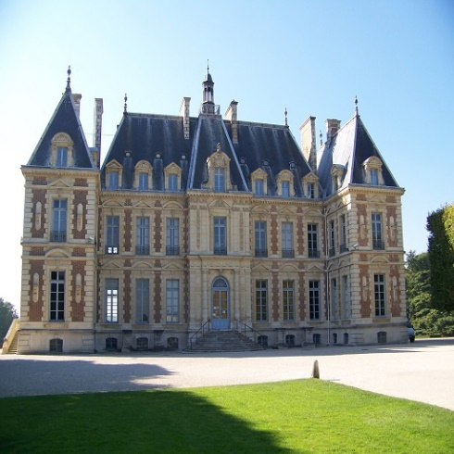

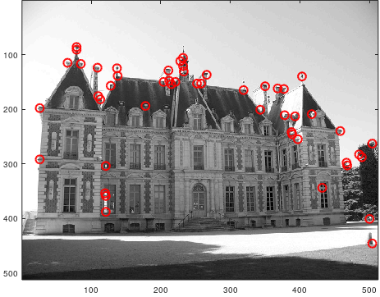

From the image sequence above, optical flow is computed in order to find the edges. First step is to convert the colored images into black and white in order to analyze the image accurately. Then optical flow field is computed. Then key points are located at edge points found in the image. Accuracy can be increased with using global functional and median filtering.

Horn and Schunck Results

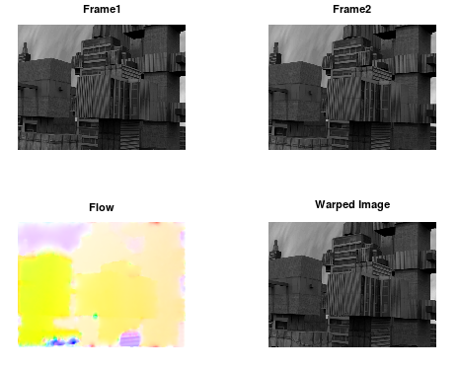Urban 3

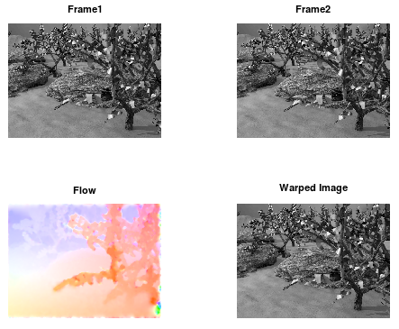Grove3

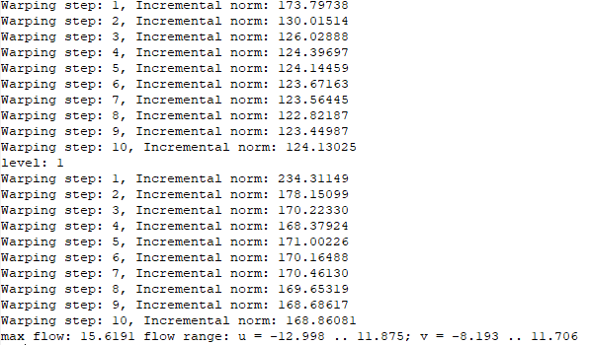

At each level each level warping is done with the increment of the optical flow. In the Horn and Schunck method warping is done in a fixed image where other images are added in top of it. There are other ways that provide more accurate warping techniques such as setting warping parameter according to image sequences.

**5)Conclusion**

Motion estimation using optical flow is a major field that has advanced throughout the past few decades. Local and global functionality for computing optical flow field were studied in this project. Due to the high usage of Horn and Schunck method, we analyzed and implemented traditional optical flow model to test its results against the modern optical flow model. As expected it was easy to understand and execute the traditional model, but it lacked when it came to the case of computing accurate optical flow field and overall performance.

Horn and Schunck method can be enhanced to reflect more accuracy and high level of performance through various modifications. My attempt of simply modifying Horn and Schunck method with Fractional-Order method turned out to be more inflexible than expected. My goal was to keep the simplicity of Horn and Schunck method while modifying the method to perform exactly as Fractional-Order method. I wasn’t able to find relationship between α, β, and L with the variables in Horn and Schunck method without changing the overall structure of original Horn and Schunck method. This would be exactly against my goal in this project, so I looked at other ways to enhance Horn and Schunck method.

By theoretically analyzing Fractional-Order optical flow we proposed to use other options to enhance the brightness constraint and energy function. Median filtering is one of the widely spread method used by researchers to enhance Horn and Schunck method. Using median filtering to reduce noise helps with image processing to compute accurate optical dense flow field. Euler Lagrange equation proposed in modified parameters section can be used in order to further resolve the noise and illumination issues.

The future work will be focused on implementing the proposed modified parameters in Horn and Schunck method to enhance motion estimation using optical flow. Horn and Schunck method is inaccurate compared to modern methods because of it lack of preserving motion discontinuity. Implementing Euler Lagrange method, median filters, and reducing smoothness effects will help reduce noise and illumination issues in the image. With the filtered image and modified equations enhanced motion estimation can be expected from traditional Horn and Schunck optical flow model.

**References**

[1] J. a/l Kanawathi, S. S. Mokri, N. Ibrahim, A. Hussain and M. M. Mustafa, "Motion detection using Horn Schunck algorithm and implementation," *2009 International Conference on Electrical Engineering and Informatics*, Selangor, 2009, pp. 83-87.

[2] B. K. P. Horn and B. G. Schunck. Determining optical flow. *Artificial Intelligence*, 17:185–203, 1981.

[3] Bin Zhu, Lianfang Tian, Qiliang Du, Qiuxia Wu, and Lixin Shi, "An Improved Fractional-Order Optical Flow Model for Motion Estimation," *Mathematical Problems in Engineering,* vol. 2018, Article ID 6278719, 6 pages, 2018.

[4] Dali Chen, Hu Sheng, YangQuan Chen, & Dingyü Xue. (2013). "Fractional-order variational optical flow model for motion estimation." *Philosophical Transactions of the Royal Society A: Mathematical, Physical & Engineering Sciences*, *371*(1990), 4

[5] J. Xu, Z. Feng and N. Lu, "Optical flow estimation with parameterized data term and warping," Proceedings of the 10th World Congress on Intelligent Control and Automation, Beijing, 2012, pp. 4633-4637.

[6] IBRAHIM, H., & ABDALAMEER, A. K. (2019). "Improvement of quantized adaptive switching median filter for impulse noise reduction in gray-scale digital images." *Turkish Journal of Electrical Engineering & Computer Sciences*, *27*(1), 580–594.

[7] F. Bartolini and A. Piva, "Enhancement of the Horn and Schunck optic flow algorithm by means of median filters," *Proceedings of 13th International Conference on Digital Signal Processing*, Santorini, Greece, 1997, pp. 503-506 vol.2.